UDC 378.147.88:004.9
Alexander Kadan
Yanka Kupala State University of Grodno
Grodno, Belarus
kadan@mf.grsu.by

ON ORGANIZATION OF MANAGED SELF-WORK OF STUDENTS WITHIN THE COURSERA FOR CAMPUS PROJECT

Abstracts: The forced transition to remote methods of organizing the educational process during the spring semester of the 2019-20 academic year forced us to look for new methods and means of ensuring and monitoring the independent work of students, using both original author's developments and the possibility of integration into international educational projects. The article provides information on the participation of employees and students of the Department of System Programming and Computer Security of Yanka Kupala State University of Grodno in the Coursera for Campus project. Participation in the project was made possible thanks to the Coursera platform policy in the context of the COVID-19 pandemic, which provided free access to more than 4,000 distance learning programs. The main attention in the work is focused on the means and services for monitoring the use of educational resources by individual students and educational groups. It is noted that the administration tools built into the Coursera for Campus platform target either individual learners or the entire community of students working on the platform. The ability to control the work of the student group, if necessary, should be implemented by additional means.
Keywords: distance learning, independent work of students, Coursera, Coursera for Campus, control of independent work, educational resources.

Кадан А.М.
Гродненский государственный университет им. Янки Купалы
Гродно, Беларусь
kadan@mf.grsu.by

ОБ ОРГАНИЗАЦИИ УПРАВЛЯЕМОЙ САМОСТОЯТЕЛЬНОЙ РАБОТЫ СТУДЕНТОВ В РАМКАХ ПРОЕКТА COURSERA FOR CAMPUS

Аннотация: Вынужденный переход к удаленным методам организации учебного процесса в период весеннего семестра 2019-20 учебного года заставил искать новые методы и средства обеспечения и контроля самостоятельной работы студентов, используя как оригинальные авторские разработки, так и возможность интеграции в международные образовательные проекты. В статье представлена информация об участии сотрудников и студентов кафедры системного программирования и компьютерной безопасности ГрГУ им.Янки Купалы в проекте Coursera for Campus. Участие в проекте стало возможным благодаря политике платформы Coursera в условиях пандемии COVID-19, обеспечившей бесплатный доступ к более чем 4000 программ удаленного обучения. Основное внимание в работе сконцентрировано на средствах и сервисах контроля использования учебных ресурсов отдельными студентами и учебными группами. Отмечается, что средства администрирования, встроенные в платформу Coursera for Campus, ориентированы либо на отдельных обучаемых, либо на все сообщество студентов, работающих на платформе. Возможность контролировать работу студенческой группы, в случае необходимости, должна быть реализована дополнительными средствами.
Ключевые слова: дистанционное обучение, самостоятельная работа студентов, Coursera, Coursera for Campus, контроль самостоятельной работы, образовательные ресурсы.

Introduction
The spread of the COVID-19 coronavirus has posed the most serious global health security threat in recent decades. In many countries, restrictions imposed by governments and government agencies have disrupted the daily lives of millions of people, including students. Many universities have temporarily suspended full-time classes, switched to hybrid education that combines social distancing requirements, classroom and distance learning, closed campuses and focused on finding solutions that would minimize the inconvenience for their students and teachers.
The issues of technical support for the organization of hybrid training quickly received a number of solutions from the leaders of the IT industry, offering free licenses for their products during the pandemic. Such solutions include Cisco's secure Webex Classrooms solution that works in conjunction with Webex Meeting [1]; Microsoft - Microsoft Teams, an enterprise platform that brings together chat, meetings, notes, and attachments in the workspace [2]; by Google - the Google Class platform integrated with Google Meet as part of the G Suite for Education platform [3].
At the same time, this does not solve the problem of the formation and integration of educational content in the context of such an unexpected transition to hybrid learning. And here world leaders in the field of distance learning, such as Coursera, have tried to say their word, which opened free access to 3,800 of its courses in 400 specialties for universities in countries affected by coronavirus, to help them organize online education for their students during the period of self-isolation or quarantine [4].

Coursera for Campus project
On October 3, 2019, the online learning platform Coursera announced a new platform Coursera for Campus, within which it invited universities - including non-partners - to use their materials in their training programs [ 4].
It was estimated that educational institutions participating in the Coursera for Campus program could access more than 3,600 Coursera programs in nearly 400 majors in engineering, business, data science, law, healthcare, art and design. Coursera programs could be used separately or integrated into courses taught at universities, participating in the Coursera for Campus program.
The Coursera initiative was supposed to open the way to address the challenges of teaching students the skills needed in the age of artificial intelligence and automation, empower universities to respond quickly to the demands of a rapidly changing economy, enable them to easily improve their existing curricula with critical digital skills and create online courses to keep up with the needs of employers.
According to Coursera, over 200 universities around the world took part in the Coursera for Campus pilot project. It was reported that over the next months the platforms will be expanded with new functionality. Among other things, Coursera for Campus users will have access to online assessment and content creation tools, including the Course Progress and Skills Index, Coursera Labs and Rhym for hands-on exercises.
At the same time, the participation of universities in the Coursera for Campus project has been considered and is still considered exclusively on a paid basis. The cost of one license was supposed to be USD 400.

Coursera's Social Distancing Policy
Taking into account the global trends in the context of the coronavirus pandemic, Coursera announced on March 17, 2020 that it will provide universities from countries affected by COVID-19 with free access to the course catalog through Coursera for Campus [5].
Initially, these institutions were supposed to have access until July 31, 2020, after which monthly extensions were planned depending on prevailing risk assessments. It has now been announced that students enrolled through Coursera for Campus by September 30th will have access to this course until November 30th, 2020.

New opportunities for organizing the educational process
In December 2019, representatives of the Yanka Kupala State University of Grodno received an invitation from Coursera to join the Coursera for Campus project. An interactive meeting was held between representatives of the educational part of the university and the European representative office of the company, during which the conditions for the university's participation in the program were announced, the company was offered assistance in forming a package of disciplines in accordance with the profile of the university, financial conditions for the university's participation in the project were presented.
The main factor that did not allow concluding a real cooperation agreement was the financial one - the cost of a license for individual access to resources within the Coursera for Campus project. The license provides access to the system using an individual login / password, which allows the student to use an individual training track, and the teacher to conduct personalized control of the educational process.

Learning management capabilities from Coursera for Campus
In the spring semester of the 2019-20 academic year, due to the ambiguous epidemiological situation in the Republic of Belarus at Yanka Kupala State University, it was decided to limit, if possible, the share of classes held in classrooms, replacing them with classes in the form of interactive videoconferences and increasing the share of controlled independent work of students.
If conducting classes in the form of videoconferencing required, mainly, the availability of skills in the field of modern IT and the improvement of the training materials developed by teachers, then when organizing controlled independent work, the lack of training materials on topics taken out for independent work, and means of monitoring the assimilation of this material became obvious.
In response to Coursera's decision to provide free access to all programs from March 17, 2020, an application was submitted on the same day to participate in the Coursera for Campus project of the Department of System Programming and Computer Security at the Yanka Kupala State Regional State University. The application was approved and the department became a participant in the project called "University of Grodno", having received, as of the current date,, 22120 licenses. The title page of the project site is shown in Fig. 1.
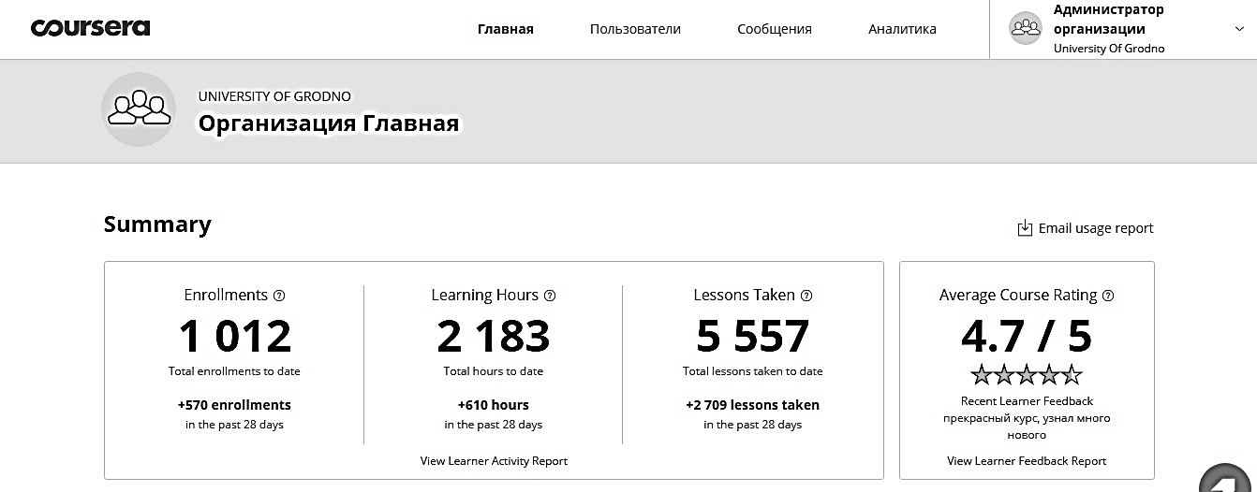
Fig. 1. Coursera for Campus "University of Grodno" project main page
The main goal of the project was to support the independent work of students in the spring period (April-June) 2020 in a tense epidemiological situation.
The project was most actively attended by students:
- 2nd year students of the specialty "Computer Security" (CS) in the framework of the academic discipline "Computational Practice" was offered the course "Methods and Means of Information Security" from the Higher School of Economics, Moscow, (https://www.coursera.org/learn/metody-i-sredstva-zashity-informacii) in Russian. The course length is 9 weeks, 74 videos with a total duration of 643 minutes, 1 material for self-study, 9 tests including 90 questions. Weekly load - 1.5-2 hours.
- 3rd year of the specialty "Computer security" in the framework of the academic discipline "Theoretical Foundations of Information Security" was offered the course "Management of Information Security" from the Higher School of Economics, Moscow, (https://www.coursera.org/learn/management-informacionnoi-bezopasnosti ) in Russian. The course length is 6 weeks, 53 videos with a total duration of 406 minutes, 7 materials for self-study, 6 tests including 60 questions. Weekly load - 1.5-2 hours.
- 1st year of the specialty "Information Resource Management" (IRM) in the framework of the academic discipline "Technologies and Systems of Electronic Business" was offered one of the most popular courses on Coursera "Marketing in Digital World" from the University of Illinois at Urbane-Champaign, USA (https://www.coursera.org/learn/marketing-digital) in English. The course length is 4 weeks, 35 videos with a total duration of 251 minutes, 18 materials for self-study, 29 tests, including 4 creative works. Weekly load - 6-8 hours.
The choice of these courses was determined either by the need to repeat the material (2nd year course of CS), or by the close content of the studied discipline and the Coursera program (3rd year course of CS, 1st year course of IRM).
It should be noted that the participation of students in the Coursera for Campus project was not limited to working only with “officially appointed courses”. Free access to the Coursera platform content and the possibility of self-selection of programs allowed students (in a limited time interval) to realize their potential, and teachers to create a more adequate picture of their interests.

Means of monitoring the degree of student activity
Unfortunately, the Coursera for Campus project's monitoring tools are focused on obtaining information about an individual student, but not about the work of a student group.
Thus, the analysis of information available through the administrator's interface allows obtaining data on the status of students' activity, generating lists of persons who:
- Joined the program
- Received an invitation, but did not join the program
- Joined but did not register
- Registered but did not pass anything
- Registered but inactive for 30 days
- Inactive for the last 90 days
- At least 1 course completed in the last 30 days
To inform students, the project administrator has a system of automatically generated messages, which allows:
- Remind students to join the program. Includes all invited students who did not join the curriculum.
- Remind students to register for a course or specialization. Includes students who have joined but have not yet registered.
- Remind inactive students of the curriculum. Includes students who have registered for the course but are not active.
- Congratulate students who have completed the course. Includes students who have completed a course or specialization.

Standard platform analytics
Standard platform analytics is based on filtering the LOG file of student activities. Sampling, data grouping and aggregation by programs and time of activities are acceptable. There are not many implemented dashboards:
- Student progress. Students enroll, study and complete courses. Allows you to track progress over time (see Fig. 2).
- Weekly progress. Students are marked as active every day as they progress through the course (eg, watching a lecture, taking a test). Shows the number of unique active students and the average number of active days for those students.
- Information on the studied programs. Contains statistics on the number of registered users, active users, and completed the course (see Fig. 3).

Additional means of monitoring the progress of the educational process
As noted above, the built-in analysis tools do not allow you to work in the essence of a "study group". At the same time, the platform allows uploading LOG-files of varying degrees of detail - a report on the use of the platform and a gradebook.
The analysis of such LOG-files allows generating reports on the work of student groups (see Fig. 4-6). Moreover, the goals of the analysis can be formed by the teacher independently and are practically unlimited. For example, it can be estimated the optimal time for students to carry out independent work, identify clusters of students who prefer "corporate training", based on the number and time of attempts spent on passing tests, identify unscrupulous students, and so on.
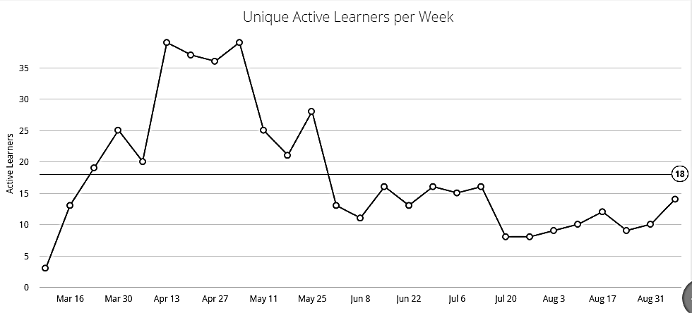
Fig. 2. Example of the Number of Unique Active Students per Week panel
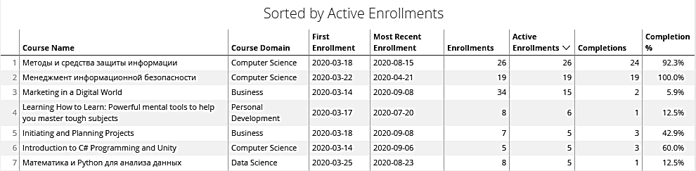
Fig. 3. An example of the panel "Information on the studied programs"

This is an extremely interesting topic, which, unfortunately, due to lack of space, we will try to develop in future works.
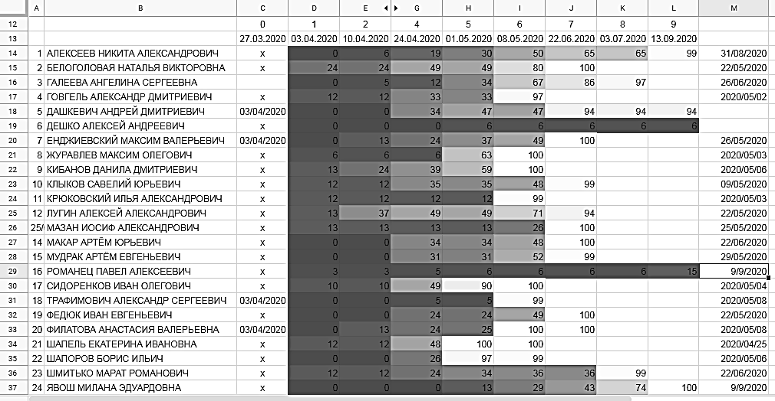
Fig. 4. Progress of student group members over time by discipline

Conclusion
The use of the Coursera for Campus platform for the short period of time during which its free use mode is valid has shown its effectiveness both in organizing guided independent work of students and in the mode of completely independent work of students. The number of programs for which students have registered, lectures listened and tests performed speaks of a conscious choice of students in favor of hybrid education.
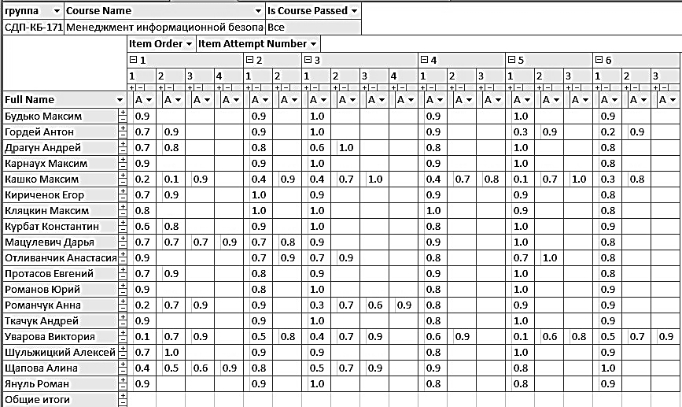
Fig. 5. Analysis of the number of attempts to pass test items in the discipline

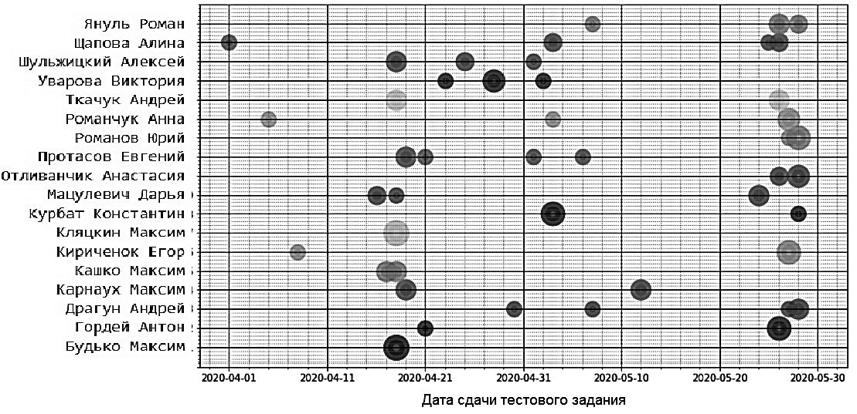
Fig. 6. Visualization of the uniformity of work by discipline (the size of the circle is proportional to the number of test tasks completed per day)

Given the commercial nature of the Coursera for Campus program, the cost of the license and the significant number of licenses for organizing effective work, it is a natural desire would be to offer to the structures of the Ministry of Education to work out solutions at the republican level that would allow universities to actively and effectively participate in such international educational projects.

Acknowledgement
I consider it my duty to express my gratitude for the help and support in my work. To my colleagues and students of the department - for their interest in new knowledge and new forms of education. Coursera staff for consultations and clarifications on the project. To Coursera manager, a graduate of the Yanka Kupala State University of Grodno, Kirill Melnichenko, without whose help and attention this project would not have acquired vitality and prospects at our university.

References

[1] Webex for Education / Cisco Webex. Retrieved August 20, 2020, from https://www.webex.com/industries/education.html.

[2] Microsoft Teams. Широкие возможности для командной работы / Microsoft – официальная страница. Retrieved August 20, 2020, from https://www.microsoft.com/ru-ru/microsoft-365/microsoft-teams/group-chat-software.

[3] G Suite for Education / Solutions built for teachers and students | Google for Education. Retrieved August 20, 2020, from https://edu.google.com/products/gsuite-for-education/?modal_active=none.

[4] Coursera for Campus / Coursera | Online Courses & Credentials From Top Educators. Join for Free | Coursera. Retrieved August 20, 2020, from https://www.coursera.org/campus.

[5] Coronavirus is giving online higher education a second chance to prove its worth / Coursera is making its courses free to students around the world — Quartz. Retrieved August 20, 2020, from https://qz.com/1817162/coursera-is-making-its-courses-free-to-students-around-the-world/.

