USING OF ARTIFICIAL INTELLIGENCE IN SOLVING THE PROBLEMS OF THE EDUCATIONAL ACTIVITY AT HIGH SCHOOL
Victor Privalov, Elena Shtrafina, Olga Voeyko

Abstract
The article discusses the tasks of introducing artificial intelligence technologies at the Technological University, Korolev in accordance with the adopted "National Strategy for the Development of Artificial Intelligence until 2030".

Key words
artificial intelligence, artificial intelligence system, personal development trajectories of students

JEL classification
С 69, С 88, O310

The Decree of the President of the Russian Federation “About the Development of Artificial Intelligence in the Russian Federation” was adopted in October 2019. This decree approved the “National Strategy of the Artificial Intelligence Development for the period until 2030”. Also the Government of the Russian Federation is ordered to develop and approve the federal project “Artificial Intelligence”.
Artificial intelligence is understood as a complex of technological solutions that allows you to simulate the cognitive functions of a person and obtain the results comparable with the results of human intellectual activity [1]. The main technologies used in artificial intelligence systems are presented in Figure 1 [2, 3].
One of the main tasks of the development of artificial intelligence in Russia is the necessity to improve the provision of Russian artificial intelligence technology market with qualified personnel.
The main directions for solving this problem are determined and presented in Fig. 2 [1].
In accordance with the “National Strategy for the Development of Artificial Intelligence until 2030”, by the end of 2024 the number of students, graduate students and specialists with competencies in the field of artificial intelligence should increase significantly [1].
Thus, in the Decree of the President of the Russian Federation and the adopted national strategy for the development of artificial intelligence, goals, objectives and priority areas for the development and use of artificial intelligence technologies are defined.

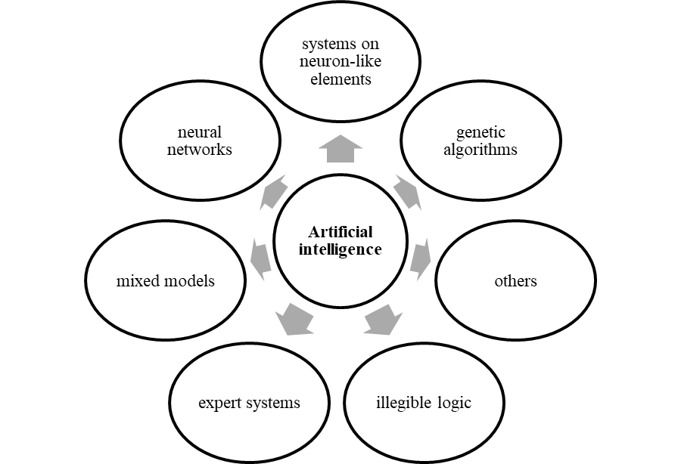

Figure 1. The main technologies used in artificial intelligence systems

Figure 2. Directions for the development of artificial intelligence in Russia
The University of Technologies has got the necessary prerequisites for the implementation of projects to create artificial intelligence systems:
- an information system has been created and modern laboratories with powerful equipment has been deployed to model processes using artificial intelligence technologies;
- a digital database of educational activities of students and lecturers has been created;
- there are lecturers who have been trained at education courses and begin to work professionally in the field of artificial intelligence;
- disciplines for the study of elements of artificial intelligence has been include in the students educational programs in the information sphere of training.
However, in modern conditions this is no longer enough. It is necessary to analyze the curriculum of students to find out if artificial intelligence disciplines are enough. It is necessary to identify significant projects together with enterprises and begin to implement this projects using artificial intelligence technologies, involving the most trained students.
Now it is possible to carry out projects using elements of artificial intelligence in the following areas (fig. 3).

Figure 3. Areas of project implementation using elements of artificial intelligence

All of these projects are doable. For their implementation, planned, organized work in this direction is necessary.

Resources
- Указ Президента РФ от 10 октября 2019 г. № 490 «О развитии искусственного интеллекта в Российской Федерации». https://www.garant.ru/products/ipo/prime/doc/72738946/
- Масленникова, О.Е. Основы искусственного интеллекта : учеб. пособие / О.Е. Масленникова, И.В. Гаврилова. — 3-е изд., стер. — Москва : ФЛИНТА, 2019. — 283 с. - ISBN 978-5-9765-1602-1
- Хайкин С. Нейронные сети. – полный курс, 2-е изд., - Москва: Вильямс, 2018. – 1104 с. – ISBN 978-5-8459-2069-0

The University of Technology, Korolev, Russia

